Compare BLER Performance of Autoencoders with Coded and Uncoded QPSK(MAX_ERROR = 100)

simulate the BLER performance of autoencoders with R=1 with that of uncoded QPSK systems. Use uncoded (2,2) and (8,8) QPSK as baselines. Compare the BLER performance of these systems with that of (2,2), (4,4) and (8,8) autoencoders.

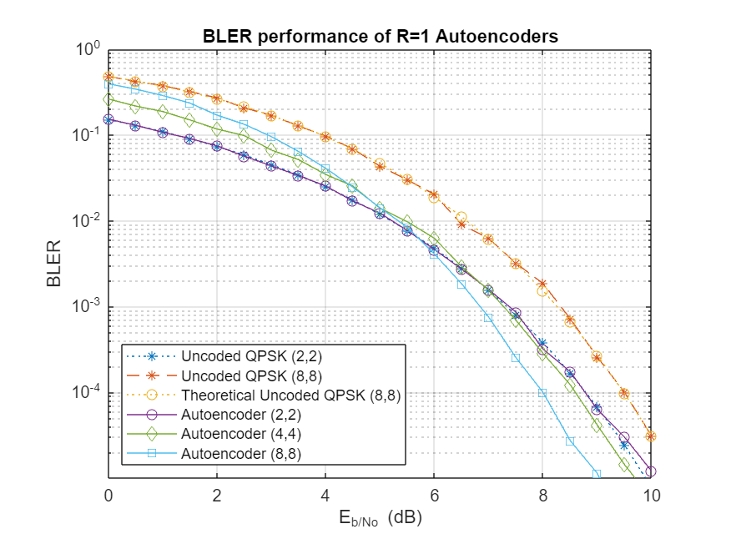

Performance Evaluation of Uncoded QAM and Autoencoder (8,8) in a Communication System

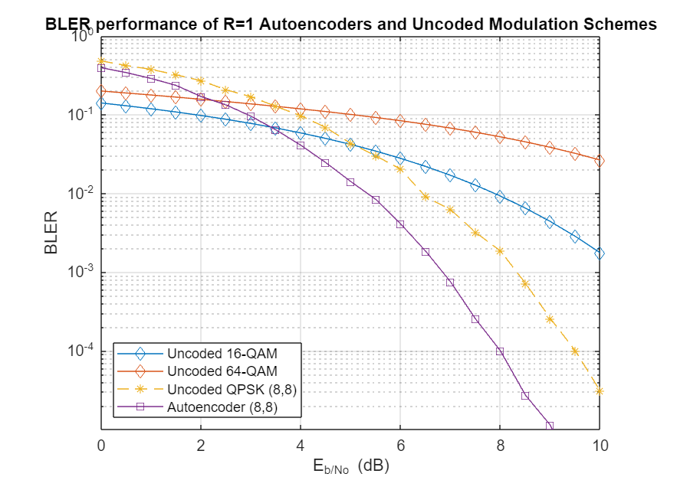

Simulate the BLER performance of a (7,4) autoencoder with that of (7,4) Hamming code with QPSK modulation for both hard decision and maximum likelihood (ML) decoding. Use uncoded (4,4) QPSK as a baseline. (4,4) uncoded QPSK is a QPSK-modulated system that sends blocks of 4 bits and measures BLER.

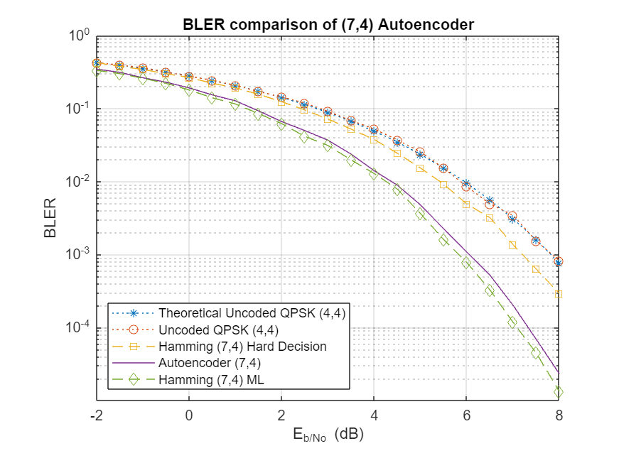

Performance Comparison of (7,4) Autoencoder with Reed-Solomon Coding (7,4).

